# Media Analysis - ChatGPT outperforms copywriters in STEP Conference’s outdoor adverts _ Updated 22 February 2023

## Short Summary

The article is about STEP Conferences using the AI tool ChatGPT for creating ad content, including taglines for outdoor ads, due to its efficiency and effectiveness in comparison to copywriters, suggesting a potential future trend of AI replacing human roles in creative industries.

## Summary

1. ChatGPT is being used by STEP Conferences to create outdoor adverts, outperforming copywriters.  
2. The company plans to continue using the AI tool for creating, summarizing, and explaining content across their team.  
3. Ray Dargham, founder of STEP Conference, stated that ChatGPT has been used for writing session briefs, creating social posts, and general copywriting.  
4. Dargham sees AI tools like ChatGPT as complementary rather than competitive, but acknowledges they may replace some human roles in the creative industry.

## Question 1

The media in this case, as represented by the Arab News article, frames the public discussion about ChatGPT in a way that emphasizes its innovative capabilities and potential impact on various industries. Metaphors used to describe ChatGPT include "brains behind" (to suggest intelligence) and "artificial intelligence assistant" (to imply utility for work). The narrative also touches upon the concept of AI as a tool that can either complement or replace human talent, with phrases like "job creation capacity," "threat posed by them," and "AI tools are more complementary than competitive." Additionally, there is an allusion to AI as a subject of popular culture through references to movies like Her and Ex Machina. However, it's important to note that the article doesn't explicitly state any fear or anxiety towards AI, which could be a different framing in other contexts.

## Question 2

The text primarily covers the following perspectives and aspects:  
  
1. The use of AI tools, specifically ChatGPT, in creative industries, particularly for content creation and summarization. This includes outdoor advertising, session briefs, social media posts, and general copy and content.  
2. The comparison between human creativity and AI-generated creativity, with a focus on the efficiency and effectiveness of using AI tools like ChatGPT.  
3. The potential impact of AI tools on jobs within creative industries, particularly for copywriters.  
4. The ongoing debate about the job creation capacity versus the potential displacement of workers by AI.  
5. The increased use of various AI tools such as Meta's Open Pretrained Transformer, Microsoft's Bing, and Google's Bard, which may further increase the use of chatbots and potentially threaten jobs in creative industries.  
  
Aspects that seem to be ignored or not explicitly mentioned in the text include:  
  
1. The ethical considerations and implications of using AI tools, particularly in a creative context.  
2. The potential backlash from human copywriters or other professionals whose jobs may be affected by the increased use of AI.  
3. Any specific training or adaptations required for ChatGPT or similar AI tools to better understand and cater to the nuances of various industries, particularly the creative industry.  
4. Long-term implications of widespread AI adoption in creative industries on the overall quality and diversity of content produced.

## Question 3

Not mentioned

## Question 4

The article suggests that ChatGPT, an AI tool, is increasingly being used by companies like STEP Conferences for content creation due to its efficiency and effectiveness in generating ideas. This shift towards AI tools might impact the role of human copywriters but also presents new opportunities for AI-assisted creativity. The final message could be summarized as "AI tools are changing the landscape of creative industries, making work faster and more efficient while posing a potential threat to traditional jobs."

## Sentiment

The sentiment is 3.0

## Entities

Microsofts Bing, Metas Open Pretrained Transformer, STEP Conferences, Dargham, Googles Bard, Ray Dargham, Art, Dargham clari ed, Arab News, STEP Conference, STEP

## Highlights

#7cc867#f9cd59#c885da#fb5b89

## Wordcloud for #7cc867 Highlights

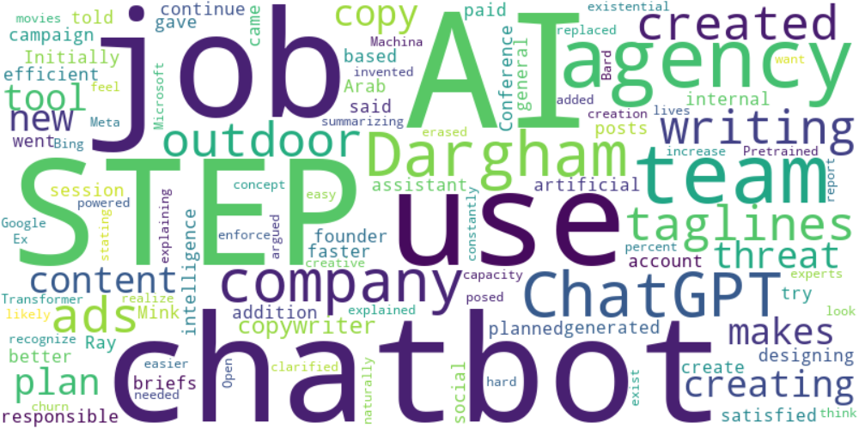

Top 10 words:

- AI: 6

- STEP: 5

- use: 4

- agency: 4

- team: 4

- like: 4

- Dargham: 3

- ChatGPT: 3

- company: 3

- chatbots: 3

## Wordcloud for #f9cd59 Highlights

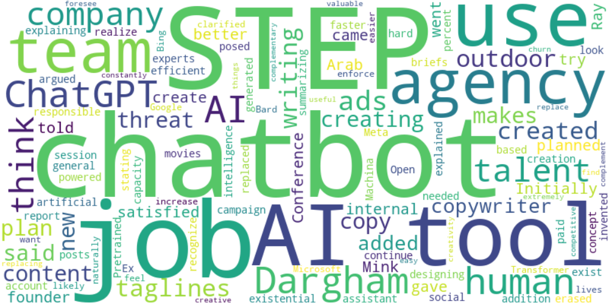

Top 10 words:

- AI: 9

- STEP: 5

- use: 4

- agency: 4

- team: 4

- Dargham: 4

- ChatGPT: 4

- like: 4

- tools: 4

- company: 3

## Wordcloud for #c885da Highlights



Top 10 words:

- AI: 6

- STEP: 5

- use: 4

- agency: 4

- team: 4

- like: 4

- Dargham: 3

- ChatGPT: 3

- company: 3

- chatbots: 3

## Wordcloud for #fb5b89 Highlights



Top 10 words:

- AI: 6

- STEP: 5

- use: 4

- agency: 4

- team: 4

- like: 4

- Dargham: 3

- ChatGPT: 3

- company: 3

- chatbots: 3